Main Page with Account dropdown

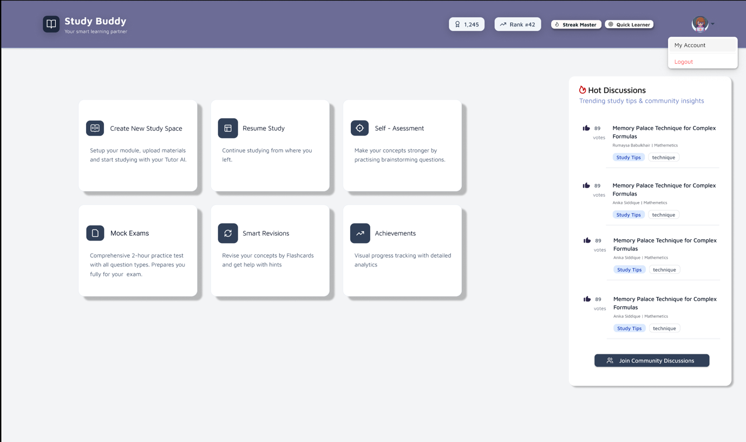

Upload File for creating new module

Invite users to join study space

Continue study page

Study Space with AI Tutor – page 1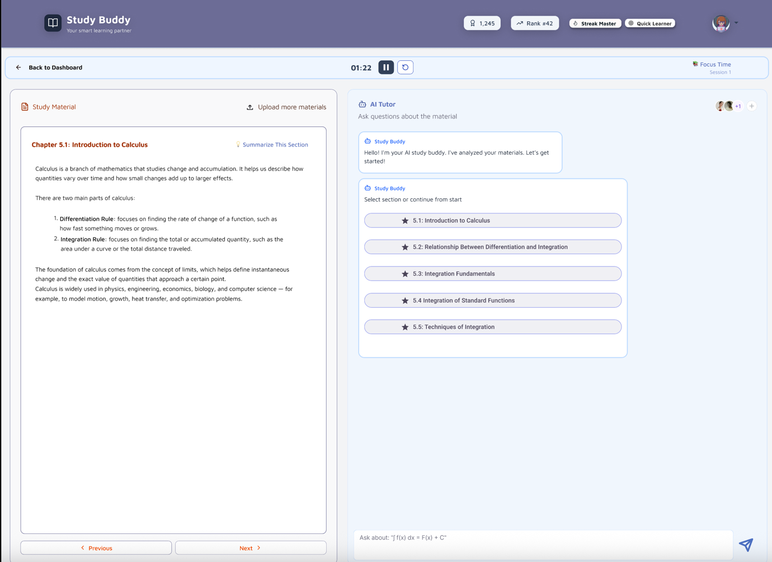

Study Space with AI Tutor – page 2

